Monte San Valentin:
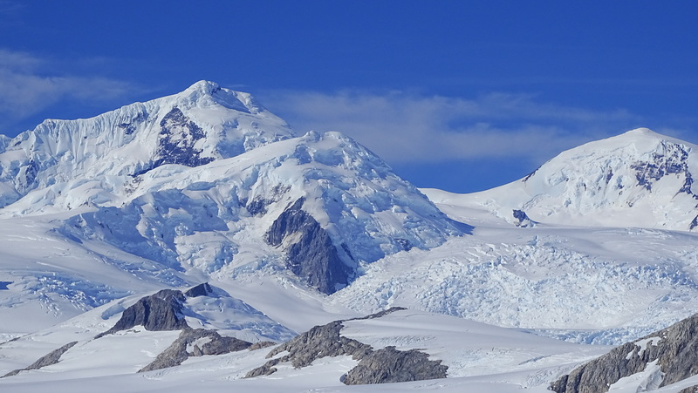
Monte San Valentín, also known as Monte San Clemente, is the highest peak in Chilean Patagonia and a prominent feature of the Northern Patagonian Icefield. This towering mountain is not only a geographical marvel but also a site of ecological, cultural, and scientific significance. Below is an expanded overview of Monte San Valentín, incorporating detailed insights and visual descriptions.
Geographical Overview
- Location: Situated in the Aysén Region of southern Chile, Monte San Valentín lies at the northern edge of the Northern Patagonian Icefield.
- Elevation: The elevation of Monte San Valentín is debated, with estimates ranging from 3,876 meters to 4,070 meters. The most commonly cited figure is 4,058 meters.
- Prominence: The mountain boasts a prominence of 3,713 meters, making it one of the most prominent peaks in South America.
- Access Routes: It can be climbed via Lago Leones to the southeast or Laguna San Rafael to the west. The ascent is long and challenging due to unpredictable weather conditions.
Visual Description
Monte San Valentín is characterized by its steep northern and eastern flanks descending into glacial forelands. The summit is perpetually covered in snow and ice, blending seamlessly into the expansive Northern Patagonian Icefield. Aerial views reveal a striking landscape dominated by outlet glaciers and glacial lakes.
Geological Composition and Formation
Monte San Valentín is part of the Andes mountain range, formed by tectonic activity resulting from the subduction of the Nazca Plate beneath the South American Plate. The region's geological history includes extensive glaciation periods that have shaped its rugged terrain. The mountain itself is composed largely of metamorphic rocks and ice-covered surfaces.
Flora and Fauna
The extreme climatic conditions on Monte San Valentín limit biodiversity:
- Flora: Vegetation is sparse at higher altitudes due to permanent ice cover. However, lower elevations support hardy plant species adapted to cold climates.
- Fauna: Bird species such as condors may be spotted in the area. Marine life thrives in nearby fjords fed by glacial meltwater.
Human Interaction
Indigenous Presence
The indigenous Kawésqar and Chono peoples historically inhabited areas near Patagonia's fjords but did not directly interact with Monte San Valentín due to its harsh environment.
Climbing History
Monte San Valentín has attracted climbers for decades:
- In December 2023, climbers Oriol Baró, Martín Elías, and Nicolás Tapia completed a challenging ascent via the north spur, navigating mixed pitches and steep ice slopes.
- In 2024, an expedition achieved the first ski descent of its south face during a rare six-day weather window.
Cultural Significance
While specific myths or legends tied to Monte San Valentín are scarce, its surrounding landscapes hold cultural importance for local communities. The mountain symbolizes natural grandeur and resilience in one of Earth's most remote regions.
Scientific Research
Monte San Valentín has been a focal point for paleoclimate studies:
- In 2005, researchers drilled a firn core on its summit to study historical precipitation patterns and climate changes over the past 45 years.
- Satellite imagery has been used to analyze cloud cover and precipitation rates in the region.
Challenges and Future Possibilities
Challenges
- Climate Change: Rapid glacial retreat poses risks to ecosystems and water supplies.
- Weather Extremes: Unpredictable weather complicates climbing expeditions and scientific research.
- Accessibility: Its remote location limits tourism potential.
Future Opportunities
- Ecotourism: Developing sustainable tourism could benefit local economies while preserving natural resources.
- Scientific Exploration: The mountain offers opportunities for further climate research.
- Cultural Documentation: Efforts could focus on preserving indigenous knowledge related to Patagonia's natural environment.
Visuals (Descriptions)
- Aerial View: An aerial photograph shows Monte San Valentín's snow-covered summit surrounded by the Northern Patagonian Icefield’s vast expanse of glaciers.
- Climbing Routes: Images from climbers depict steep ice walls and mixed pitches leading to the summit.
- Ski Descent: Photos from 2024 show mountaineers skiing down its south face amidst breathtaking icy landscapes.
Monte San Valentín stands as a testament to nature’s power and beauty, offering endless opportunities for exploration and discovery. Its unique combination of geographical prominence, ecological significance, and human interaction makes it a fascinating subject for continued study.
References:
- https://en.wikipedia.org/wiki/Monte_San_Valent%C3%ADn
- https://peakvisor.com/peak/monte-san-valentin.html
- https://www.cambridge.org/core/journals/journal-of-glaciology/article/evaluation-of-cloudiness-over-monte-san-valentin-northern-patagonia-icefield-from-2000-to-2008-using-modis-satellite-images-implications-for-paleoclimate-investigations-from-ice-cores/3B640D1836DF43C688CBB4EE1CFE1EE5
- https://explorersweb.com/new-route-patagonia-cerro-san-valentin/
- https://publications.americanalpineclub.org/articles/13201216825
- https://www.anden.at/en/montesanvalentin.php
- https://www.planetmountain.com/en/news/alpinism/first-ski-descents-monte-san-valentin-patagonia-altos-de-los-arrieros-chile.html

